- ReadMe
This program is written in MIPS Assembly. Please read the following instructions:
- Download the IDE(Mars) for MIPS Assembly at http://courses.missouristate.edu/KenVollmar/mars/
- After installation, run the IDE.
- Click open and select the file of the program:
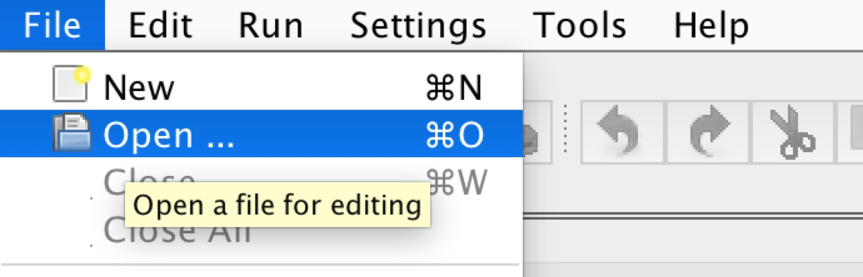
- Assemble the file by clicking the left-most button on the following graph:
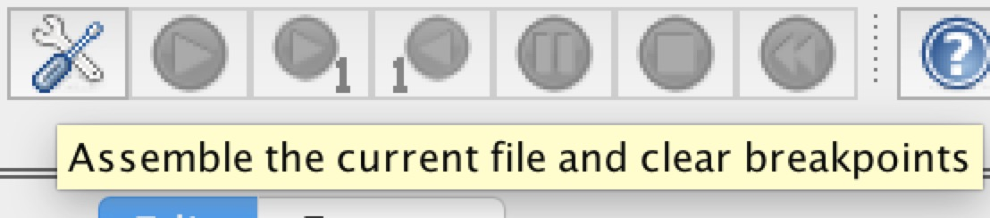

- Run the program by clicking the button:

- There are two options for you to choose:
- Press 1 to create a new student file.
- Press 2 to search an existing student file.
- Press 3 to remove an existing student file.
- Press 4 to print all student information.
- Press 5 to calculate the total average
- Press 6 to quit program.

8.Sample Output
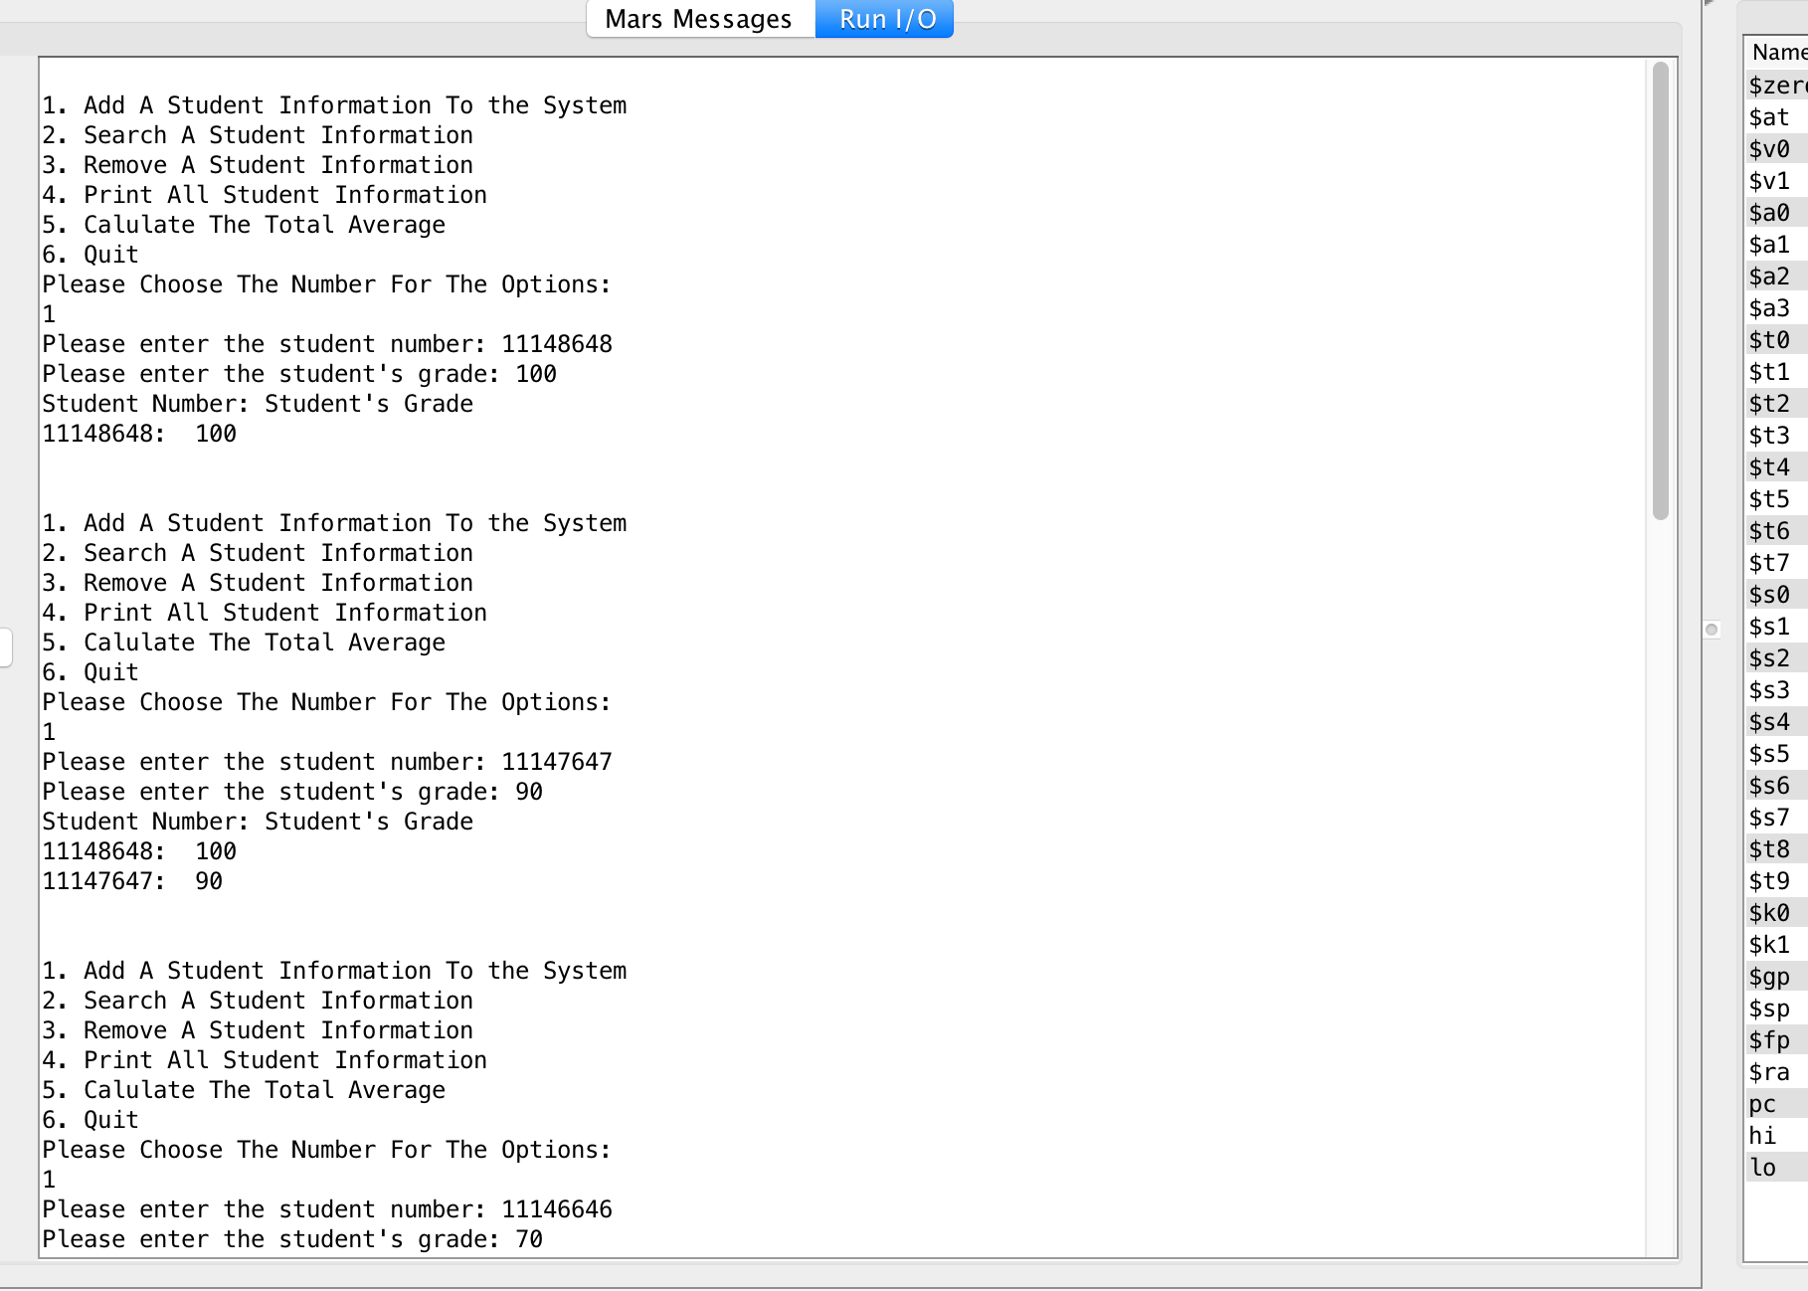
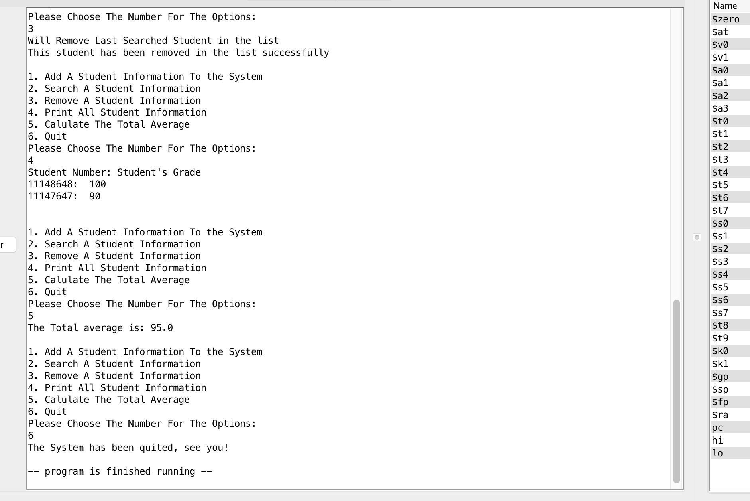

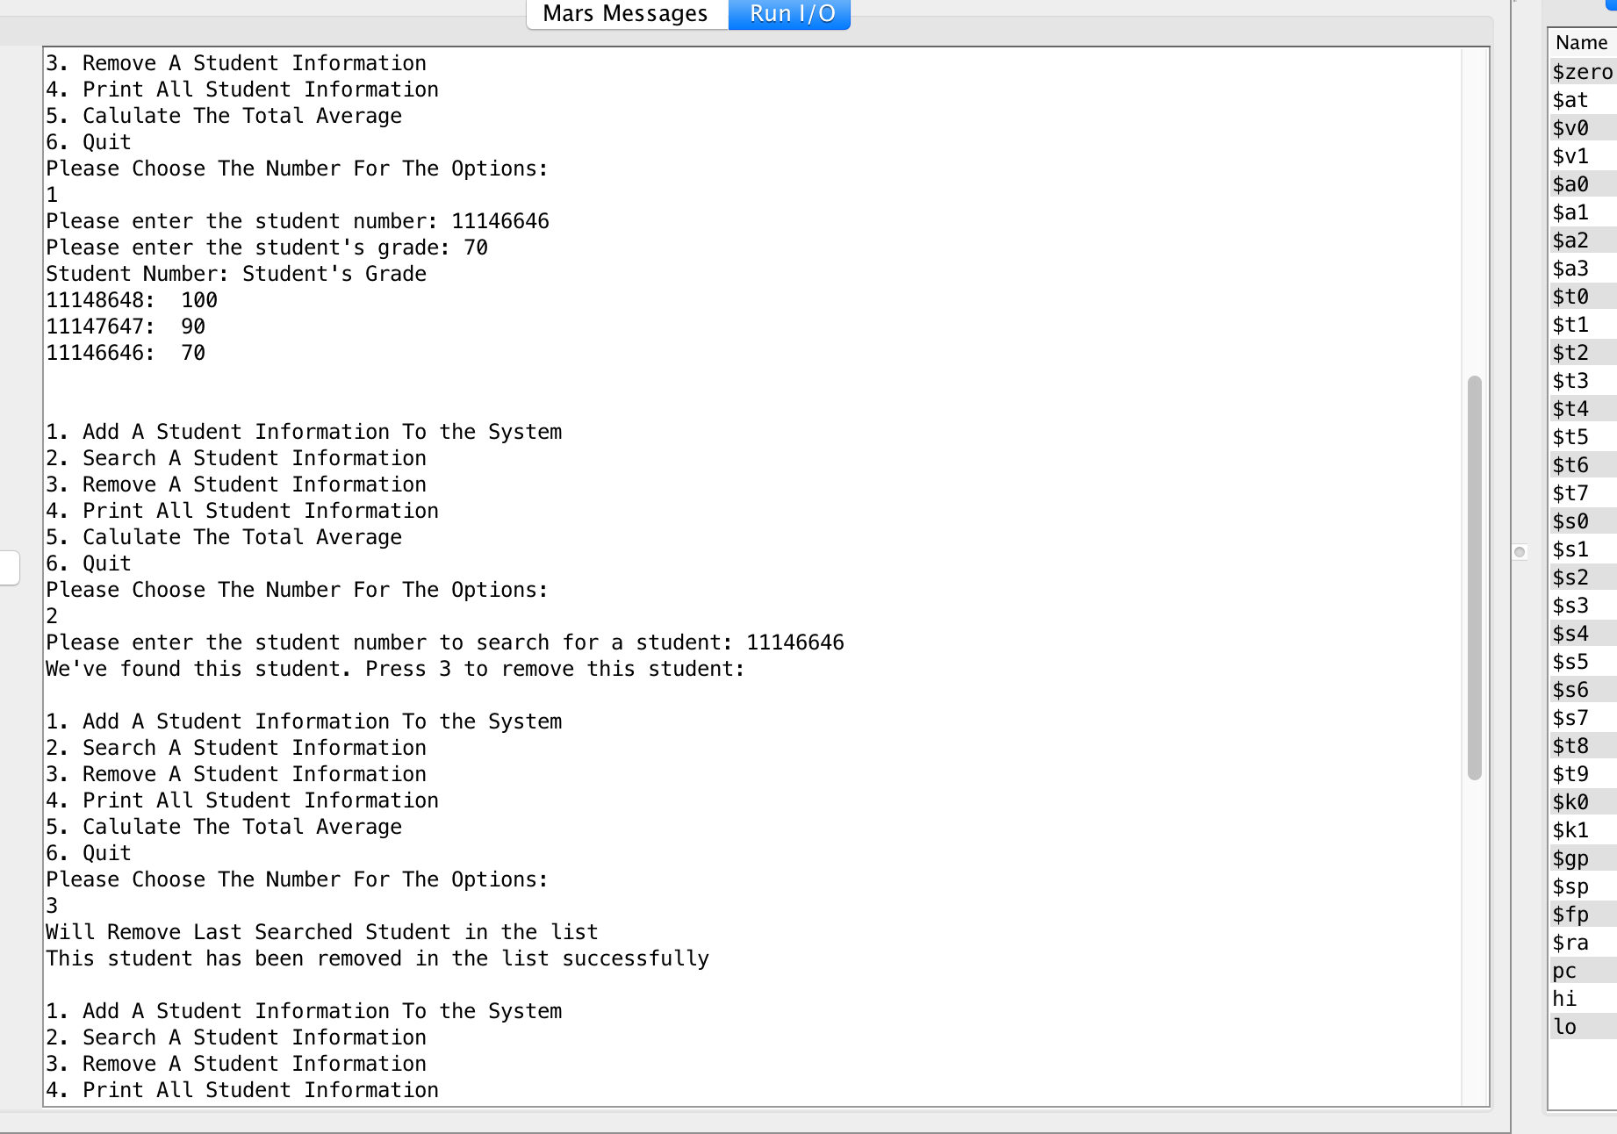
9.SVN log: https://svn.cs.usask.ca/svn/student/215/hello215/
